Neighborhood Associations [chōnai-kai]

１ Neighborhood Association Activities & Purposes
In recent years, along with the significant changes in urbanization and socio-economic conditions, progress in the diversification of people's values and way of life has led to normalization of valuing the individual lifestyle and not getting involved or interfering in the lives of others. There are also concerns about human relations and solidarity within communities, and the weakening of residents’ spirit of mutual assistance.
It is under the kind of social conditions described above that another look is being taken at the role of the neighborhood association. That is because it is now known that during large disasters such as the Great Hanshin Earthquake and the Great East Japan Earthquake, in communities where the neighborhood associations were well organized, rescue, evacuation guidance, confirmation of residents’ safety, shelter management, food handouts and so on went more smoothly, which contributed greatly to ensuring residents’ safety. Help from neighborhood associations and voluntary disaster preparedness organizations is most reliable, because large-scale disasters can paralyze a city, limiting the government’s ability to respond. In these times of emergency, the link developed between community members through regular activities in more usual times will demonstrate its value.
Even in Okazaki, during the torrential rain of August 2008, two people lost their lives, and there was a great deal of property damage which affected over 3,000 homes and included a bridge collapse, a landslide, and so on. After the rain stopped, neighborhood associations and the city government coordinated in grasping the scope of the damage and disposing of the debris and worked together in order to restore residents to their everyday lives. Currently, a variety of disaster prevention measures are being advanced while confirming the state of affairs in the community. Community cooperation has become indispensable in efforts to develop a city that is strong amid disasters such as localized torrential rains and so on.
Neighborhood associations have a long history, and they continue to exist because of various problems in everyday life (sanitation, traffic safety, disaster preparedness, crime prevention, welfare, etc.) which residents resolve through mutual cooperation and coordination with the goal of making the town a better place. A community is a place for day-to-day life and its suitability as a clean and safe environment is an irreplaceable asset to its residents. Neighborhood associations bear an important role in building a habitable community and maintaining it over generations.
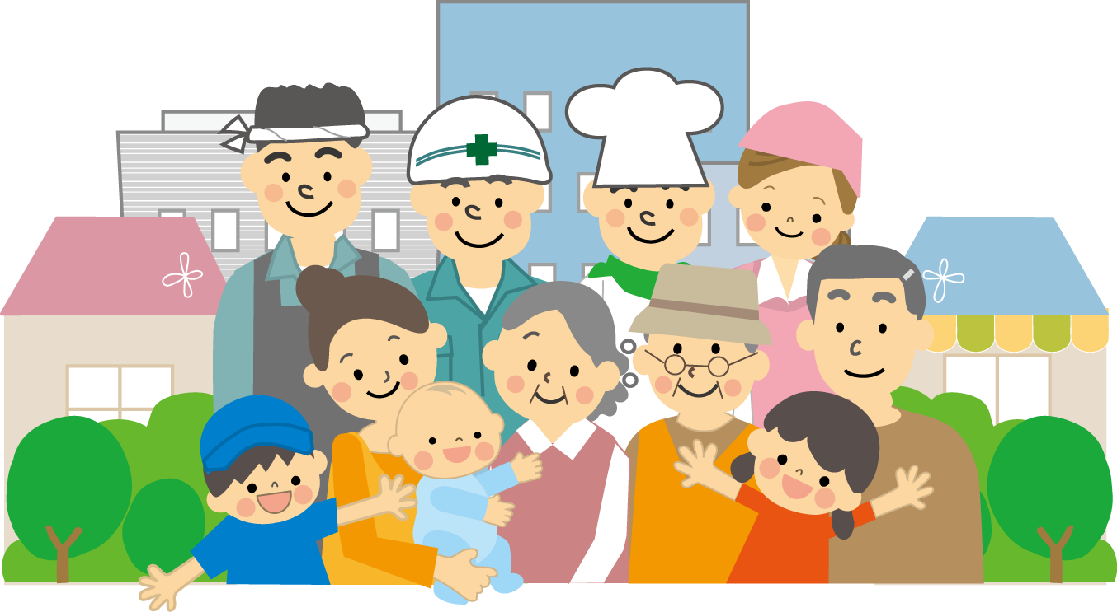

2 Functions of a Neighborhood Association
Communities are composed of people from a wide range of ages, from children to the elderly, and family circumstances such as household composition and occupation of all different kinds exist. In addition, urban centers, upcoming residential areas, rural areas, and so on have their own special characteristics.
Accordingly, the function of neighborhood associations varies from community to community; however, on the whole their functions include the following.
⑴ Social Functions (communication, sports, recreation, athletic meets, festivals, etc.)
The most fundamental thing for the optional gatherings that are neighborhood associations is for communication between residents to go smoothly. Through events and other opportunities for exchange, trust between community members is heightened.
⑵ Collective Security (Disaster, crime, fire, traffic safety measures, etc.)
No one knows when or where a disaster will occur. There are many cases, such as fires, crime, accidents, and so on, when people must help each other, and protect lives and property collectively, instead of being left to act alone. It is necessary to decide roles and conduct training exercises during normal times, so that in case of emergency the community is able to respond.
⑶ Environmental Maintenance (drainage, street lights, roads, trash, cleanup, etc.）
In order to make a pleasant and beautiful town, in addition to maintenance of facilities and institutions from a public health perspective, continuation of cleanup of roads and gutters and mowing of grass is desired.
Additionally, requesting to the local government for installation of street lamps and traffic safety equipment, repairs to dangerous places on the road, and so on can increase the safety of the community.
⑷ Complementing the Government (distribution of information, fundraising, etc.)
Neighborhood associations play a part in broadly conveying living information to residents through distribution of the Shisei Dayori (city newsletter) and use of circular notices. In addition, they cooperate and help coordinate a number of city-wide initiatives.
⑸ Realization of Purposes (Petitioning or making demands of authorities, etc.)
One of the major roles of neighborhood associations is to get community members to use their abilities to solve community problems, but there are many problems residents cannot resolve on their own. In order to solve that kind of problem, another important role of neighborhood associations is to do things like petition authorities or make requests to them on behalf of the community.
⑹ Neighborhood Representation (residents’ opinions & interests)
There are also many problems which residents of a neighborhood may face for which the government cannot get involved. At times like that, it is important to grasp the opinions, requests or demands that residents have, discuss them thoroughly, and reconcile different interests to solve problems that are shared throughout the neighborhood.
⑺ Mutual Support (Helping the bereaved, collecting resources, etc. )
When worst comes to worst it is community members who can help each other. The number of elderly people living alone is increasing, and there are many things that require cooperation among members of the community.
⑻ Preservation of Traditions (Maintenance of local cultural assets, holding traditional events, passing along traditions, etc. )
There are some communities where traditional events remain from long ago. Also, in newly-developed areas, it is also possible to create new specially made customs for the sake of the children. Through preservation of traditions and cultivation of new culture, people can grow up to be proud of their hometowns.
⑼ Education & Learning
There are many people who would like to make use of their experience somewhere. If there are many types of activity that make use of those people’s special skills, then the cultural value of neighborhood associations can increase and lead to richer human relations.

3 Promoting Neighborhood Association Membership
It is ideal to have all households join a neighborhood association. A common framework is for every household in the community to be entered into the neighborhood association as a self-governing association for collective community management. This is of course not compulsory. Needless to say, the feeling “let’s improve our town with our own hands” should be fundamental to joining a neighborhood association.
However, these days due to the increase of housing developments, large apartment buildings and single-occupancy apartments and so on it can be quite a difficult situation to get people to understand membership in a neighborhood association. In that case, first explain the goals and workings of a neighborhood association; deepening understanding is important. When these types of buildings are constructed a manager or superintendent is assigned, and that person is in charge of coordinating communications. Therefore, one method can also be to consult with the manager (or the managing company) about entry into neighborhood association membership.
Whatever the case may be, in order to get every household in the community to join the neighborhood association, mutual understanding and cooperation between all residents is indispensable, and persistent efforts will be necessary.
Please refer to the next page, it illustrates an example of a guide for non-members to joining a neighborhood association.
Neighborhood Association Membership Guide Template

Welcome to the 〇〇-cho Neighborhood Association！

You are a member of group ◯◯ of the 〇〇 Neighborhood Association

These days there is a clamor to create a society that brings people together. The first step towards that begins with members of the community greeting each other casually, talking to each other, and developing a rapport.
As you are aware, neighborhood associations are organizations of residents for building a better town. For advancement toward the goal of building a city that we can be proud is easy to live in and where people wish to continue living, the ◯◯ Neighborhood Association was formed under the motto “building a cheerful town worth living in.”
Living in a society presents us with many common problems, such as installment and management of garbage stations, community beautification, disaster measures, crime prevention, traffic safety, and so on. When it comes to these matters, surely there is a need to consider these problems and act to solve them as a community. Additionally, the information provided by the City and the fun opportunities for neighbors to get acquainted are indispensable.
For that purpose, we would like for many community residents to become members and help in making the town better together.
Now that you understand our purpose, we would like to ask you to become a member of our association. For more information on how to become a member, or to ask a question about our association, please use the detail below to contact one of our representatives.
◯◯ Neighborhood Association Contact Information:
President ◯ ◯ ◯ ◯ ℡〇〇－〇〇〇〇
Group Manager ◯ ◯ ◯ ◯ ℡〇〇－〇〇〇〇
